Batch: A2 Roll No.: 16010122034

Experiment / assignment / tutorial No. 03

Grade: AA / AB / BB / BC / CC / CD /DD

Signature of the Staff In-charge with date

TITLE :Multi-dimensional Arrays (Jagged Array)

AIM: Write a program which stores information about n players in a two dimensional array. The array should contain the number of rows equal to the number of players. Each row will have a number of columns equal to the number of matches played by that player which may vary from player to player. The program should display player number (index +1), runs scored in all matches and its batting average as output. (It is expected to assign columns to each row dynamically after getting value from the user.
_____________________________________________________________________
Expected OUTCOME of Experiment:

CO2: Explore arrays, vectors, classes and objects in C++ and Java.
______________________________________________________________________
Books/ Journals/ Websites referred:

- E. Balagurusamy , “Programming with Java” McGraw-Hill.

- Sachin Malhotra, Saurabh Choudhary, “Programming in Java”, Oxford Publications.
_____________________________________________________________________
Pre Lab/ Prior Concepts:

Arrays
Multi-Dimensional Array:
10 12 43 11 22
20 45 56 1 33
30 67 32 14 44
40 12 87 14 55
50 86 66 13 66
60 53 44 12 11
A multi-dimensional array is one that can hold all the values above. You set them up like this:
int[ ][ ] numbers = new int[6][5];
The first set of square brackets is for the rows and the second set of square brackets is for the columns. In the above line of code, we're telling Java to set up an array with 6 rows and 5 columns.
aryNumbers[0][0] = 10;
aryNumbers[0][1] = 12;
aryNumbers[0][2] = 43;
aryNumbers[0][3] = 11;
aryNumbers[0][4] = 22;
So the first row is row 0. The columns then go from 0 to 4, which is 5 items.
Class Diagram:

Class name | Exp3
Variables | -
Functions | main()

Algorithm:
1. Start
2. Take n Input
3. Initialize 2D array row
4. Loop n times
- Take number of matches as input
- Initialize column as number of matches +1
- Store first element of every row as jersey number
Loop m times
- Take number of runs as input
- Store in 2D array
5. Print Player Stats
- Print Player Number
- Print number of matches
- Calculate total runs and print
- Print Batting Average i.e. Total runs/ Number of matches

Implementation details:
import java.util.Scanner;
class Runs {
public static void main(String[] args) {
Scanner sc = new Scanner(System.in);

System.out.println("Enter the Number of players:");
int n = sc.nextInt();

int players[][];
players[][] = new int[n][];

for(int i=0; i<n; i++){
System.out.println("Enter number of matches played by player " + (i + 1) + ": ");
int matches = sc.nextInt();
players[i] = new int[matches];

for(int j=0; j < matches; j++){
System.out.println("Enter the runs made by player " + (i + 1) + "in match " + (j + 1) + ": ");
players[i][j] = sc.nextInt();
}
}

System.out.println("\nRuns made by each player in the matches they played:");
for (int i = 0; i < n ; i++){
System.out.print("Player " + (i + 1) + ": ");
int total = 0;
for (int j : players[i]){
total += j;
System.out.print(j + " ");
}
System.out.print("Average: " + (total / player[i].length));
System.out.println();
}
}
}

Output:
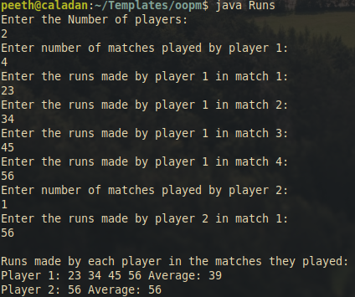
Conclusion:
This experiment involved studying multidimensional and jagged arrays. The latter was used for implementing the given problem statement and achieving desired results

Date: 22 August, 2023 Signature of faculty in-charge

Post Lab Descriptive Questions

Q.1 Create a jagged array of integers. This array should consist of two 2-D arrays. First 2-D array should contain 3 rows having length of 4,3,and 2 respectively. Second 2-D array should contain 2 rows with length 3 and 4 respectively.
public class Jagged {
public static void main(String[]args){
int arr1[][]=new int[3][];
arr1[0]=new int[4];
arr1[1]=new int[3];
arr1[2]=new int[2];
int arr2[][]=new int[2][];
arr2[0]=new int[3];
arr2[1]=new int[4];
System.out.println("array 1");
for(int i=0;i<arr1.length;i++){
for(int j=0;j<arr1[i].length;j++){
System.out.print(arr1[i][j]+" ");
}
System.out.println();
}
System.out.println("\narray 2");
for(int i=0;i<arr2.length;i++){
for(int j=0;j<arr2[i].length;j++){
System.out.print(arr2[i][j]+" ");
}
System.out.println();
}
}
}

Output
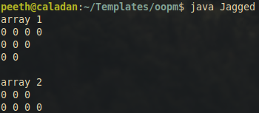

Q.2 Consider the following code
int number[] = new int[5];
After execution of this statement, which of the following are true?
(A) number[0] is undefined
(B) number[5] is undefined
(C) number[4] is null
(D) number[2] is 0
(E) number.length() is 5

(i) (C) & (E)
(ii) (A) & (E)
(iii) (E)
(iv) (B), (D) & (E)

Ans: (iv) (B), (D) & (E)

Q.3 Write a program to create an array where the i^{th} row has i columns.
class RowsColumns {
public static void main(String[]args){
int arr1[][]=new int[5][];
for (int i=0;i<arr1.length;i++){
arr1[i]=new int[i+1];
for(int j=0;j<arr1[i].length;j++)
System.out.print(arr1[i][j]+" ");
System.out.println();
}
}
}
Output
